# FNDB020 Accounting

Tutorial Questions

Week 9:

Goods & Services Tax

& Accounting Systems

**Updated April 2016**

|  |  |
| --- | --- |
| **DISCUSSION QUESTIONS** | **HOGGETT 9E , Chapter 3** |

*Discussion Question 9, page 112*

**Message for Instructors:** (in your own words, please explain the paragraphs in red. This will be provided in the students’ solutions)

9. *Explain why when a business pays GST on the purchase of goods or services it records this as GST Outlays (GST Receivable) and an asset. When a business provides goods or services for which are taxable it records the GST component of the transaction as GST Collections (GST Payable), a liability.*

Important facts:

* The future economic benefit controlled by the entity makes GST Outlay (or GST Receivable) an asset used as a reduction in future cash outflows to the ATO by reducing the amount of GST it has to forward to the ATO.

* When a business provides goods and services for which are taxable under the GST legislation it is in effect collecting tax on behalf of the ATO that it is then liable to forward to the ATO. This is why this GST Collections (or GST Payable) is a liability and it will result in a future cash outflow to the ATO.

* When a business pays GST on purchasing goods or services it is allowed to offset this GST Outlays against and GST it owes (GST Collections) to the Australian Taxation Office (ATO).

Explain (to students and highlight the main concepts):

The amount of GST Outlays (GST paid on purchase) is offset when:

* The amount of GST paid (for purchases) is less than the amount that the business collected from the customers (GST collections). The GST paid is used to reduce the amount of GST collected (during sales/services) on behalf of the ATO. Bob Trading will remit (send) the net GST Collections (payable) to the ATO:

**Required:**

***Exercise 1:*** *For the month of March, Bob’s Trading sold $50 000 plus GST (to customers) and purchased $30 000 plus GST (from suppliers). How much GST does he owe the ATO?*

Answer:

GST Collections - GST Outlays

= GST Payable - GST Receivable

= ($50 000 x 10%) – ($30 000 x 10%)

= $5 000 - $3 000

= $ 2 000

Bob will have to remit $2 000 (send) to the ATO

Note: Here, Bob has offset (reduced) the GST Collections by the GST Outlays

• The amount of GST paid exceeds (is more than) the amount that the business collected from the customers (GST collections). The GST paid is used to reduce the amount of GST collected on behalf of the ATO. Bob Trading will receive a refund from the ATO for the net GST Outlays (receivable).

***Required:***

***Exercise 2:*** *For the month of April, Bob’s Trading sold $50 000 plus GST (to customers) and purchased $70 000 plus GST (from suppliers). How much GST does he owe the ATO?*

GST Collections - GST Outlays

= GST Payable – GST Receivable

= ($50 000 x 10%) – ($70 000 x 10%)

= $5 000 - $7 000

= -$ 2 000

Bob expects to receive a refund (ATO will repay $2 000)

Note: The result of Bob offsetting (reducing) the GST Collections by the GST Outlay is -$2 000 or a refund (ATO will pay Bob back).

## Revision on Goods and Services Tax; Journal Entries with GST

Einstein Electronics is an online retailer of electronic project kits. He supplies to many hobbyist. Each electronic kit sells for $770 (including $70 GST) or $700 plus GST. The electronic kits are purchased from a manufacturer for $440 each

(including $40 GST per item) or $400 plus GST.

Einstein has completed an introductory accounting course and has prepared the following information required for the GST calculations:

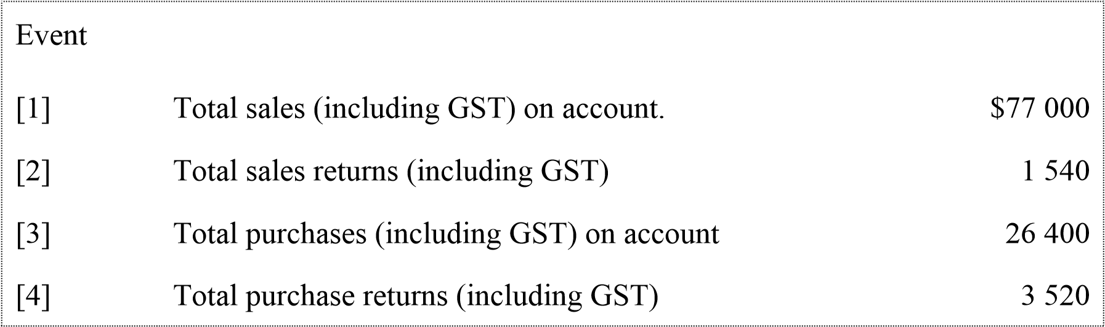

Einstein is unable to prepare the journal entries for GST transactions and has turned to you to assist him:

***Required:***

Journalise the sales and purchases transactions, as well as the payment of GST to the tax authority, using GST Outlays and GST Collections accounts.

Selling Inventory:

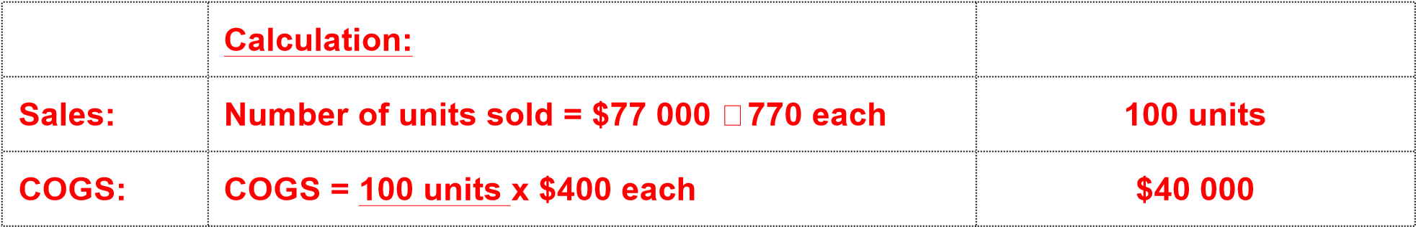

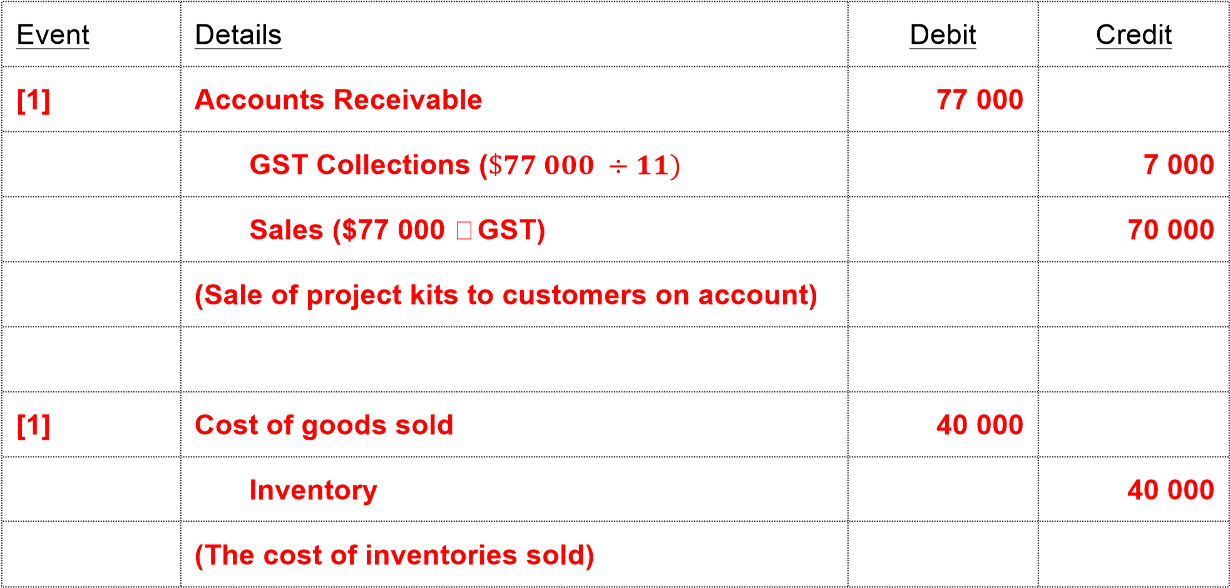

Sales returns and allowances

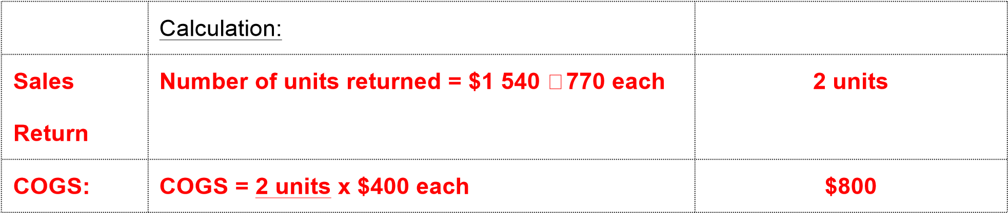

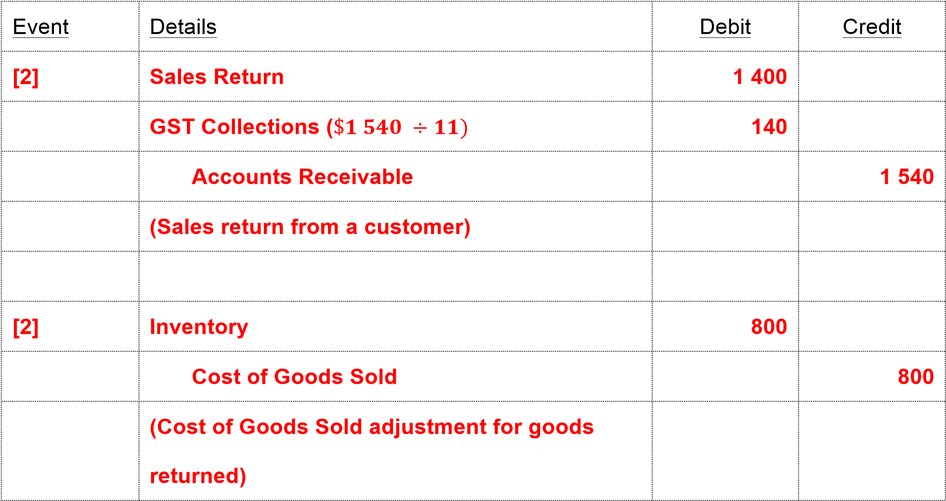

Purchasing Inventory

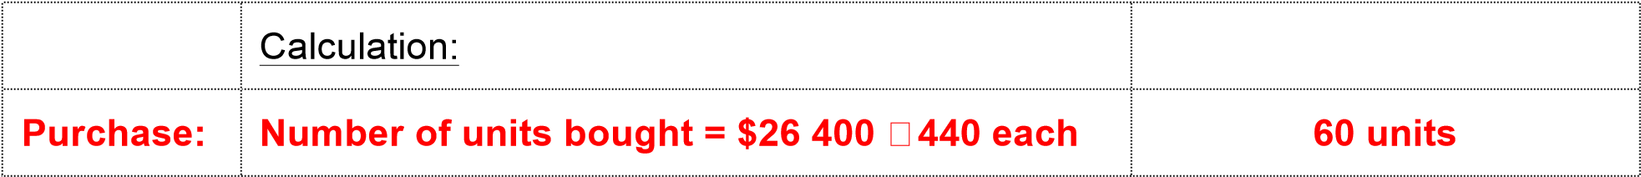

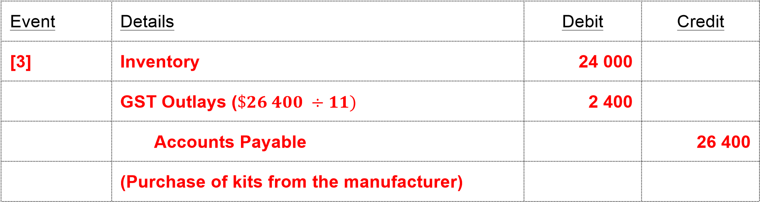

Purchases return

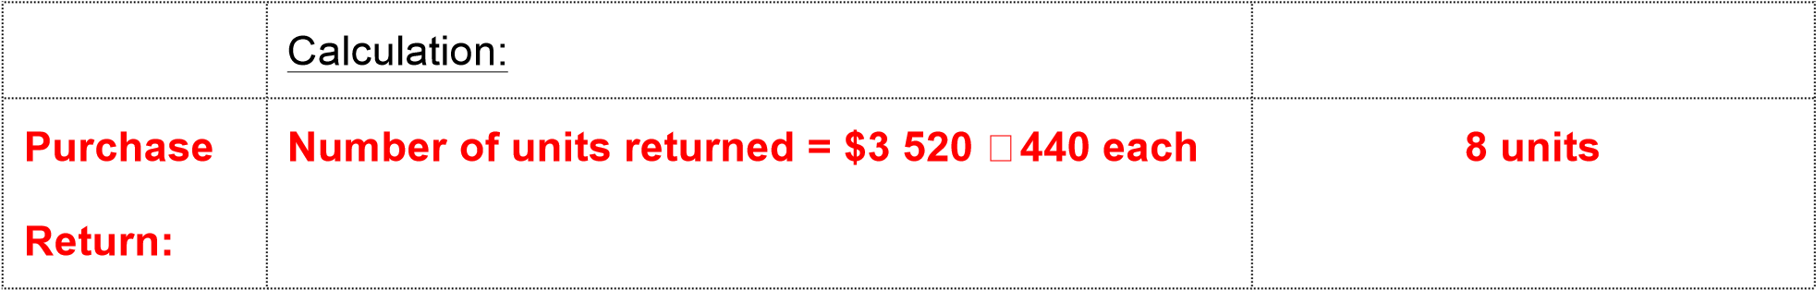

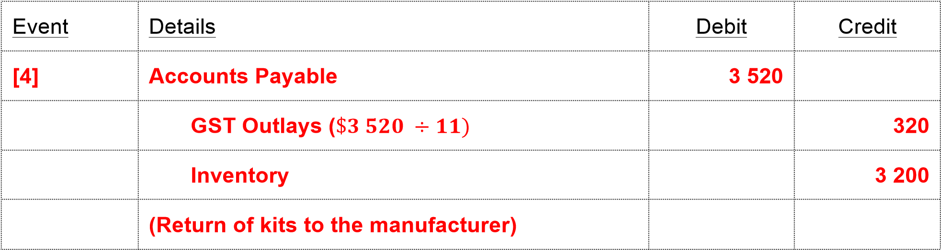

## EXERCISE SOLUTIONS

|  |
| --- |
| **Exercise 7.1** |

**Subsidiary ledger and control account**

*(source: HEM 9E, p 319)*

*J. Fry uses subsidiary ledgers and special journals in his accounting system. The accounts in the accounts payable subsidiary ledger for the most recent month are shown below:*

Accounts Payable Subsidiary Ledger

*Note: Accounts Payable means J.Fry owes the suppliers and this liability (Credit) is the opening balance or Balance b/d.*

*Legend: CP = Cash Payments (CPJ) ; P = Purchases on account (PJ)*

**E. Koumi**

**A. Packer**

CP

150

Bal (c/d) 50

Bal. (b/d)

P

$

0

200

CP

180

Bal (c/d) 460

Bal. (b/d)

P

P

$

180

250

210

200

200

**640**

640

Bal. (b/d)

**50**

Bal. (b/d)

**460**

**T. Trinh**

**Y. Yue**

CP

230

Bal (c/d) 515

Bal. (b/d)

P

$

490

255

CP

195

Bal (c/d) 310

Bal. (b/d)

P

$

195

310

745

745

505

505

Bal. (b/d)

**515**

Bal. (b/d)

**310**

***Required***

1. *Prepare the Accounts Payable Control account showing the final balance of the account, assuming that all transactions are reflected in the above accounts.*
2. *Prepare a schedule of accounts payable to reconcile the subsidiary ledger with the control account.*

**Answers:**

